Microservices with Spring Boot 3 and Spring Cloud

## Step 1: Create Account Microservice

**a) Go to** [**https://start.spring.io**](https://start.spring.io)**:**

* **Group:** com.cognizant
* **Artifact:** account
* **Dependencies:**
  + Spring Web
  + Spring Boot DevTools

**b) Download and Extract ZIP**

* Extract the project.

**c) Import into Eclipse:**

* **Eclipse → File → Import → Existing Maven Projects →** Select account folder **→ Finish**

**d) Configure Controller**

In com.cognizant.account.controller package, create AccountController.java:  
  
@RestController

@RequestMapping("/accounts")

public class AccountController {

@GetMapping("/{number}")

public Map<String, Object> getAccountDetails(@PathVariable String number) {

Map<String, Object> response = new HashMap<>();

response.put("number", number);

response.put("type", "savings");

response.put("balance", 234343);

return response;

}

}

**e) Run the Project**

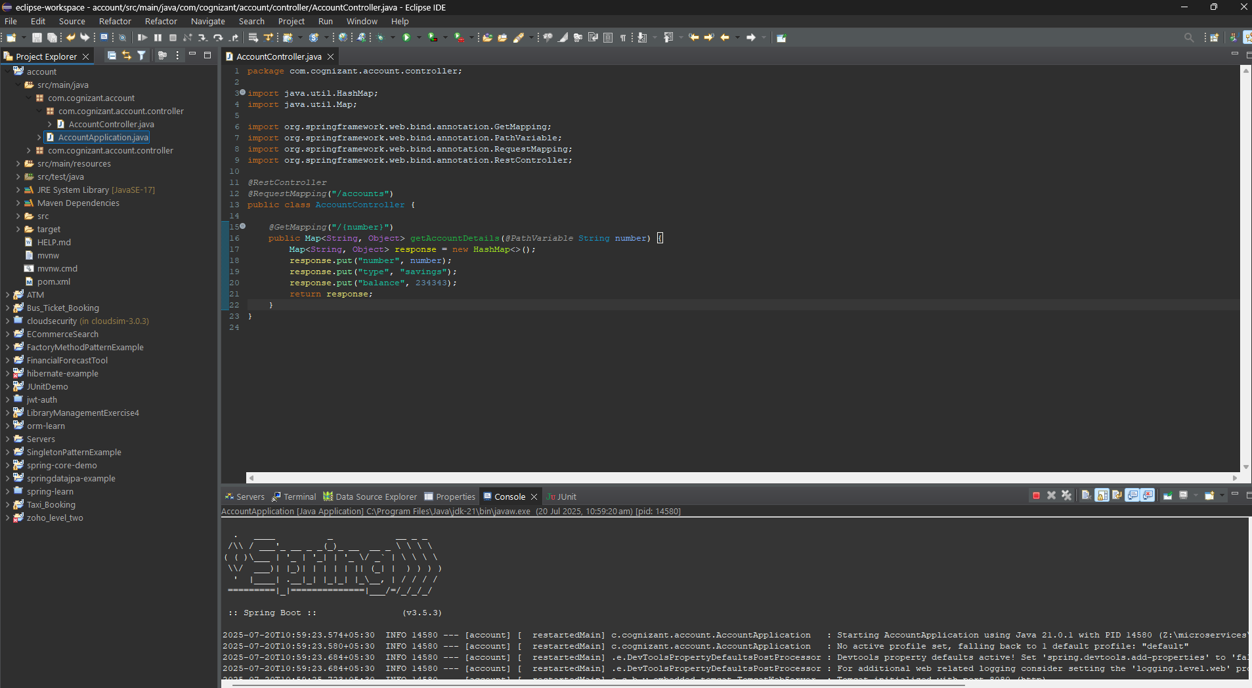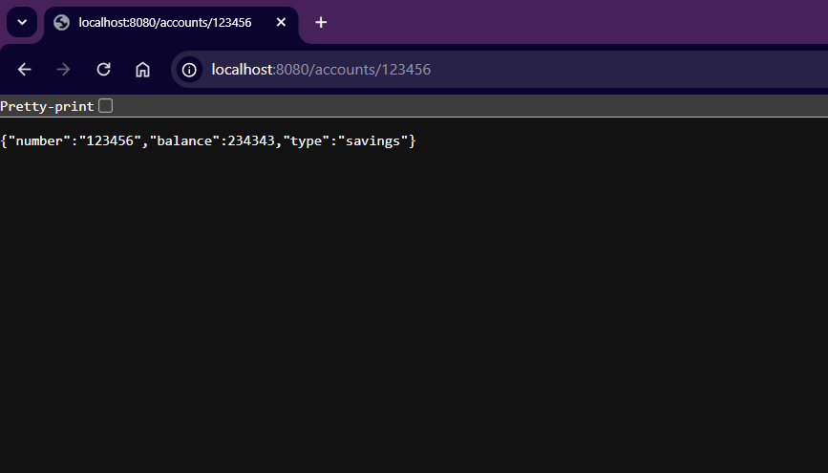

## Step 2: Create Loan Microservice

**a) Go to** [**https://start.spring.io**](https://start.spring.io)**:**

* **Group:** com.cognizant
* **Artifact:** loan
* **Dependencies:**
  + Spring Web
  + Spring Boot DevTools

**b) Download and Extract ZIP**

* Extract the project.

**c) Import into Eclipse:**

* **Eclipse → File → Import → Existing Maven Projects →** Select account folder **→ Finish**

**d) Configure Controller**

In com.cognizant.loan.controller package, create LoanController.java:  
  
@RestController

@RequestMapping("/loans")

public class LoanController {

@GetMapping("/{number}")

public Map<String, Object> getLoanDetails(@PathVariable String number) {

Map<String, Object> response = new HashMap<>();

response.put("number", number);

response.put("type", "car");

response.put("loan", 400000);

response.put("emi", 3258);

response.put("tenure", 18);

return response;

}

}

**e) Change Port in application.properties (so both services run):**

server.port=8081

**f) Run the Project  
